**Segmentation and shielding as elements of an exit strategy from COVID-19 lockdown**

**Bram A.D. van Bunnik1,2, Alex L.K. Morgan2, Paul Bessell3, Giles Calder-Gerver1, Feifei Zhang1, Samuel Haynes2, Jordan Ashworth1, Shengyuan Zhao1*,* Nicola Rose Cave2, Meghan R. Perry4, Hannah C. Lepper1, Lu Lu1, Paul Kellam5, Aziz Sheikh1, Graham F. Medley6 &Mark E.J. Woolhouse1,2**

1Usher Institute, University of Edinburgh, Edinburgh, UK. 2School of Biological Sciences, University of Edinburgh, Edinburgh, UK. 3The Roslin Institute, University of Edinburgh, Edinburgh, UK. 4Clinical Infection Research Group, Regional Infectious Diseases Unit, Western General Hospital, UK. 5Department of Medicine, Division of Infectious Diseases, Imperial College London, UK. 6Centre for Mathematical Modelling of Infectious Disease, London School of Hygiene and Tropical Medicine, London, UK.

Summary

In this study we demonstrate that the adoption of a segmenting and shielding (S&S) strategy could increase scope to partially exit COVID-19 lockdown while limiting the risk of an overwhelming second wave of infection.

We illustrate the S&S strategy using a mathematical model that explores the effects on the epidemic curve of a gradual ramping up of protection for the vulnerable population and a gradual ramping down of restrictions on the non-vulnerable population over a period of 12 weeks after lockdown.

The most important determinants of outcome are: i) post-lockdown transmission rates within the general population segment and between the general and vulnerable segments; ii) the fraction of the population in the vulnerable and shielder segments; iii) compliance with need to be protected; and iv) the extent to which population immunity builds up in all segments.

We explored the effects of extending the duration of lockdown and faster or slower transition to post-lockdown conditions and, most importantly, the trade-off between increased protection of the vulnerable segment and fewer restrictions on the general population.

We illustrate how the potential for the relaxation of restrictions interacts with specific policy objectives. We show that the range of options for relaxation in the general population can be increased by maintaining restrictions on the shielder segment and by intensive routine screening of shielders.

We find that the outcome of any future policy is strongly influenced by the contact matrix between segments and the relationships between social distancing measures and transmission rates. These relationships are difficult to quantify precisely so close monitoring of the epidemic would be essential during and after the exit from lockdown.

Introduction

As of 25/04/2020, 2,719,897 confirmed COVID-19 cases and 187,705 COVID-19 related deaths had been reported globally [WHO, 2020]. Countries around the world have imposed severe social distancing measures – ‘lockdown’ – on their entire population to reduce the rate of spread of infection. These measures cause huge (though not fully quantified) societal, psychological and economic harm [OECD, 2020] so there is an urgent need to find ways of exiting lockdown safely.

Here, we consider one option for facilitating exit from lockdown: segmenting and shielding (S&S). Segmenting is dividing the population into groups that are relatively homogeneous in healthcare characteristics or needs [Low et al., 2020]. Shielding is a way to protect people who are especially vulnerable to severe COVID-19 outcomes by minimising all interaction between them and other people [British Lung Foundation, 2020].

S&S addresses the concern that while the economic, social and psychological costs of lockdown are distributed across the entire population the public health burden is highly concentrated in identifiable populations of persons “vulnerable” to COVID-19.

Key risk factors for vulnerability to COVID-19 are defined by the World Health Organisation (WHO) as those over 60 years old and those with underlying medical conditions (such as cardiovascular disease, diabetes, chronic respiratory disease, and cancer) [WHO, 2020]. Although risk factors for severe COVID-19 disease are still incompletely understood, the UK has identified 1.5 million potentially vulnerable individuals and issued specific advice to shield themselves from infection (Table S1).

There have been numerous mathematical modelling studies of the actual and predicted impact of social distancing measures on COVID-19 epidemics [e.g. Leung et al., 2020; Chatterjee et al., 2020; Bayham et al., 2020; Tuite et al., 2020; Kim et al., 2020; Prem et al., 2020; Block et al., 2020]. Very few have explicitly considered shielding [McKeigue and Colhoun, 2020; Neufeld et al., 2020; Weitz et al., 2020] and, despite its inclusion as part of national and international strategy for responding to COVID-19, shielding is not included by any of the mathematical models being used to inform policy in the UK, nor (to the best of our knowledge) any other country. One modelling study in the UK concluded that social distancing of those over 70 years old (including a 75% reduction of contacts outside home and workplace) would contribute to reducing the burden on the National Health Service (NHS), though lockdown would still be needed to keep burden within NHS capacity [Ferguson et al., 2020].

We therefore constructed a mathematical model designed to explore the complex trade-offs between maintaining or increasing protection for some population segments (shielding) and maintaining or relaxing restrictions on other segments. Key features of our approach include: i) explicit representation of the contact structure between three population segments: vulnerable (v), shielders (s) and the general population (g); and ii) rapidly decaying post-infection immunity.

We use the model to explore the potential of S&S to meet specific policy goals for the UK, namely: i) to save lives; ii) to prevent NHS capacity being overwhelmed; and iii) to protect NHS staff. We consider three, increasingly restrictive, specific objectives that are consistent with these policy goals:

1. future level of infection in the vulnerable population to be kept below the level at the start of lockdown;
2. future levels of infection in the entire population to be kept below levels below levels at the start of lockdown;
3. no further increase in numbers of cases or deaths at any time.

Objectives (1) and (2) would allow levels of infection to rise in at least some segments at some point in the future. We emphasize that we do not regard any level of infection in any subset of the population as acceptable: COVID-19 can be a serious disease in all age groups and risk groups. However, we posit that COVID-19 in the non-vulnerable population could be managed using a conventional response, centred around good clinical care and proportionate public health measures, without resorting to lockdown.

Methods summary

We developed a susceptible-infectious-resistant-susceptible (SIRS) compartment metapopulation model. Briefly, the population is divided into equal-sized segments with frequency-dependent transmission occurring between segments (see Supplementary Methods for full details). Each segment is comprised of individuals from either the vulnerable, shielder or general populations. The contact structure for the baseline realisation of the model is shown in Figure 1.

We use the model to explore plausible scenarios for the dynamics of a COVID-19 epidemic during exit from lockdown. We do not make specific predictions; there are too many uncertainties about the epidemiology of COVID-19 for anything other than short-term extrapolations of epidemiological data to be robust. However, we are able to explore the trade-offs that exist between increasing protection for the vulnerable population segments and relaxation of restrictions for non-vulnerable segments. We discuss below how the outputs of the model can be used to inform policy.

Key considerations are the definition of and the size of the vulnerable population. Our approach is informed by public health guidance in the UK; age and specified underlying health conditions are of primary concern. We therefore consider a set of models including some or all of the following categories:

* individuals >=70 years old (differing from the WHO criterion);
* individuals in receipt of government advice to shield;
* care home residents, those receiving care in the home and hospital patients.

We enumerated these categories using published data [Burton et al., 2019; BLF, 2020; NHS, 2020; ONS, 2019]. For our baseline scenario we designated 20% of the total population as vulnerable. We assumed a 1:1 ratio of shielders to vulnerable. The remaining 60% of the population are not in either category and we refer to this as the 20-20-60 model. We estimate that the relative risk of severe disease in the vulnerable 20% is 16:1 (see Supplementary Methods).

We also considered alternative scenarios where the most vulnerable 14%, 8% or 2% are shielded and attributed relative risks of severe disease to these fractions (see Supplementary Methods). We assumed that the smaller the vulnerable population the fewer of their contacts were with the general population: ranging from 3 in 5 for the 20-20-60 model to 1 in 5 for the 2-2-96 model (see Supplementary Methods).

SIRS model parameters were informed by the UK’s Reasonable Worst Case values R0=2.8 and doubling time=3.3 days, giving an infectious period of 8.57 days and recovery rate γ=1/8.57 days = 0.117 day-1 [National Commissioning Group, 2020].

The contact structures in infectious disease models may be informed by empirical data, e.g. from the POLYMOD study [Mossong et al., 2008]. However, such studies cannot inform COVID-19 modelling given the huge impact of social distancing measures on behaviour. Moreover, the POLYMOD study did not explicitly consider contacts between the vulnerable, shielder and general population segments. We therefore used as simple as possible contact structure that captures the key features of interest here.

Transmission rates, β values, were allowed to vary over four phases (P1-P4). Prior to lockdown (P1) we assumed fully homogenous contact between segments, noting that this implies a force of infection from the general population three times higher than from the vulnerable or shielder populations (Figure 1). We chose β values to give P1 Re=1.7, reflecting measures already in place immediately before lockdown, including voluntary self-isolation of cases and quarantining of affected households. During lockdown (P2) we assumed lower values for all β’s including some impact of the shielding advice already in place, giving Re=0.8 for the vulnerable population and 0.9 for others. Over a 12-week period after lockdown (P3) we varied β values linearly towards a final value either greater than (relaxation) or less than (protection) P2 values, after which (P4) they remained constant. See Supplementary Methods for full details of β values used.

Initial conditions for the baseline model were chosen to give a cumulative fraction exposed, R(t) = 0.06 at t=78 days (one week after start of lockdown), consistent with emerging serological data [PHE, 2020].

Results

The baseline simulation for the 20-20-60 model generated a scenario in which the combination of increased protection of the vulnerable population and partial relaxation of restrictions for the rest of the population allow a second wave of infection to occur, peaking in the vulnerable population on 111 days after the end of lockdown (Figure 2A). In the vulnerable population the peak was lower than the first peak, but in the other segments it was higher. For this scenario, the percentage of the severe disease burden occurring in the vulnerable population is reduced from 80% to 60% (Table 1).

The modelled changes in β values (Figure 2B) translated into changes in the underlying effective reproduction number, R­e. For our baseline simulation during Phase 4 although Re<1 for the vulnerable population it was >1 in both non-vulnerable segments (highest in the general population) and overall (Figure 2C). This has two implications. Firstly, that outbreaks in the vulnerable population are self-limiting and, secondly, that the eventual decline in the epidemic is due to the build-up of population immunity (Figure S1). We note that P2 Re<1 implies that if lockdown were continued then levels of infection in all segments would eventually fall to very low levels.

We conducted a series of sensitivity analyses on model parameters.

Extending P2 beyond 6 weeks resulted in peaks that were delayed (by less/more than the extension to the lockdown) but were slightly higher (Figure S2). Extending or shortening Phase 3 by ±6 weeks resulted in peaks that were XX days later or XX days earlier respectively but were of similar magnitude (Figure S3).

Varying the start of P2 relative to the epidemic curve had a major impact on subsequent dynamics (Figure S4). This reflects substantial differences in the fractions exposed to infection and therefore the build-up of population immunity. Notably, if the lockdown started earlier in the epidemic curve than estimated (lower I(t)) then the risk of an overwhelming second wave is substantially greater (Figure S4A).

Varying P2 β values (and so Re) had an effect on epidemic dynamics, not altering the qualitative outcome but substantially affecting numbers of cases in all three subpopulations (Figure S5).

Varying P3/4 β values had a substantial effect on epidemic dynamics, and could alter the outcome. If P4 Re is greater than X.X then the second Iv peak exceeds the height of the first (Figure 3A).

Variation in compliance of the vulnerable population during P3/4 was modelled as an impact on β1 and β4 values (Table M3), 100% compliance corresponding to the baseline scenario target values and 0% to a return to Phase 1 values. Assuming that compliance has a linear effect on β1 and β4 values, if compliance is less than XX% then the second Iv peak can exceed the height of the first (Figure 3B).

Varying R­e throughout also had a significant impact on the outcome. At higher Re values the second peak remained low, but at slightly lower values than our baseline scenario (<1.63 in P1) the second Iv peak exceeds the height of the first peak (Figure 3C). This is because a smaller fraction was exposed in the first wave of the epidemic, so there was less population immunity.

Varying the rate of loss of immunity, ζ, also had a significant impact on whether the second peak in the vulnerable population exceeded the first (Figure 3D). At longer average duration of immunity (1/ζ) the second peak remained low, but for shorter durations (<54 days) it exceeds the height of the first peak. This illustrates that epidemic dynamics are highly sensitive to the duration of immunity and its impact on the development of population immunity.

Fourier Amplitude Sensitivity Test (FAST) analysis indicated that key outcomes are differentially sensitive to variation in individual or sets of β values (Figure 4). Three outcome measures were assessed: height of the second peak; whether the second peak is higher than the first; and cumulative incidence over one year. The value of transmission parameters within the general population and between the general and vulnerable populations have the greatest impact on outcomes.

There is a clear, though asymmetric, trade-off between increasing protection of the vulnerable population and relaxing restrictions on the non-vulnerable population (Figure 5A). This trade-off can be expressed in terms of combinations of protection and relaxation that meet specific policy objectives (Figures 5B-D). The more restrictive the policy objectives (increasing from 5B to 5D) the smaller the parameter space that satisfies those objectives.

The higher the ratio of shielders to vulnerable (taken to be 2:1; 1:1 or 0.5) the more the second peaks were delayed and suppressed (Figure S6). This reflects that different fractions of the total population (more or fewer shielders) are subject to greater restrictions.

Moving from the 20-20-60 model to the 14-14-72, 8-8-84 and 2-2-96 models, i.e. decreasing the vulnerable fraction and increasing the proportion of their contacts with shielders, allowed higher and earlier second peaks (Figure S7). This resulted in increased cumulative incidence in both the vulnerable and the shielder plus general population segments (Table 1). At the same time the fraction of the severe disease burden in the vulnerable segment decreased. Together, this makes S&S less effective for narrower definitions of the vulnerable segment.

The 20-20-60, 14-14-72, 8-8-84 and 2-2-96 models generate different trade-offs in terms of combinations of protection and relaxation that meet specified policy objectives (Figure 6). The trade-offs are complex but two key patterns are apparent: as the size of the vulnerable fraction is decreased there is: i) a larger parameter space where no policy objective is satisfied; and ii) much less scope for increasing β3, i.e. the rate of contact within the general population. These constraints can be partially eased by keeping β2 as low as possible, i.e. minimizing contacts between shielders and the general population.

Discussion

We note several caveats to our findings. We used relatively simple models to explore a wide range of scenarios. These scenarios are not predictions; in our view there are too many uncertainties about the epidemiology of COVID-19 to make robust predictions beyond short-term projections of epidemic data. There are three important sources of uncertainty that may influence our results:

1. The contact structure between and within segments is not well quantified. We carried out an extensive sensitivity analysis (Figure 4) to identify critical elements of the contact matrix.
2. Relaxing restrictions and increasing protection both involve changes in behaviour. These are difficult to predict in advance though they can be monitored in close to real time [Jarvis et al., 2020].
3. Further, the relationships between behavioural changes and transmission rates are also difficult to predict so close monitoring of the epidemic remains essential.

Given these limitations, we simulated a range of plausible scenarios, consistent with available data. We find that a combination of increased protection of the vulnerable population and relaxation of restrictions (lockdown) on the non-vulnerable population can prevent an overwhelming second wave of the COVID-19 epidemic in the UK.

This result is driven by the build-up of population immunity during the first wave, particularly in the non-vulnerable population (Figure S1). The extent of population immunity for COVID-19 is uncertain [Kellam & Barclay, 2020]. However, our analysis suggests that even short-lived population immunity will have a significant effect. It has been argued that short-lived immunity (average duration c. 1 year) will allow multiple waves of infection over many years [Kissler et al., 2020]. In the absence of any acquired immunity to COVID-19 the epidemic becomes significantly more difficult to control (Figure S8).

Other key drivers are the size of the vulnerable population and their relative risk of severe infections. A smaller vulnerable population may be logistically easier to protect, and perhaps more likely to comply, but is likely to incur a smaller proportion of the severe disease burden. At the same time, a consequence of protecting a smaller proportion of the population and relaxing restrictions for a larger proportion is that overall transmission rates are higher. The implication is that S&S will be much more difficult to implement successfully if the proportion of the population designated vulnerable is too small. That said, as risk factors for severe COVID-19 infections become better understood it should be possible to define the vulnerable population more precisely.

Sensitivity analyses suggest that the most influential transmission rates are those between the vulnerable and general population segments (Figure 4). This is important because these rates can be reduced by social distancing, which is considerably more difficult to do for the shielders. However, the same analysis also underlines the importance of transmission within the general population, which is the main reservoir of infection. It is therefore vital that transmission rates are kept as low as possible, even if this population is allowed to exit lockdown. Measures including self-isolation of cases, quarantining of affected households, contact tracing and voluntary social distancing will be necessary to achieve this.

In all our scenarios the vulnerable segment is subject to increased protection indefinitely. S&S is also more likely to succeed if there is less or no relaxation of restrictions on shielders. Both these observations underline the importance of both identifying the vulnerable and shielder populations as precisely as possible and of developing strategies for protection/shielding that minimise the disruption to normal activities, not least to ensure high levels of compliance.

Policy objectives also impact on the range of S&S strategies that could be used. The most restrictive policy objective we considered – not allowing any increase in the number of cases – cannot currently be achieved without social distancing measures. This leaves very little room for relaxing lockdown measures even with greatly enhanced protection for the vulnerable.

A key component of S&S is behavioural modification, not only for the vulnerable and shielder segments but also for the general population. We note that appropriate advice could be issued quickly and cheaply, making this suitable for any country affected by COVID-19.

In addition, S&S could be greatly strengthened by infrastructure and technological support for effective biosecurity, both at institutional (e.g. care homes, hospitals) and household levels in order to keep transmission rates low between and within shielders and vulnerable populations. For maximum effectiveness biosecurity requires training, high standards of hygiene, effective personal protective equipment and screening of everyone in contact with the vulnerable population.

Intensive screening would, ideally, include daily checks for symptoms, daily tests for virus presence (preferably with results available the same day to prevent pre-symptomatic transmission), regular serological testing and monitoring of frequent contacts (e.g. household members) of shielders. If too large fraction of the population were to be classified as ‘shielders’ this would quickly overwhelm current testing capacity in the UK. Nonetheless, routine rapid testing of shielders could have a significant impact and further increase the scope for relaxing restrictions on the entire population (Figure S9).

Finally, we note that S&S would not be implemented in isolation. Measures such as contacting tracing (both traditional and app-based) could also facilitate exit from lockdown [Kucharski et al., 2020]. In the long term effective therapeutics and vaccines may alleviate the need for restrictive social distancing measures. Even then, however, we anticipate that COVID-19 biosecurity will need to be built into the daily routines and working practices of all hospitals, care homes, other vulnerable institutions and some households, affecting everyone who resides in, works in, or visits those locations.

References

Bayham, J. & Fenichel, E. P. Impact of school closures for COVID-19 on the US health-care workforce and net mortality: a modelling study. Lancet. Public Heal. (2020). doi:10.1016/S2468-2667(20)30082-7

Block, P., Hoffman, M., Raabe, I. J., Beam Dowd J., Rahal, C., Kashyap, R., Mills, M. C. Social network-based distancing strategies to flatten the COVID-19 curve in a post-lockdown world (2020).

British Lung Foundation. Coronavirus and COVID-19: What is social shielding and who needs to do this? (2020). [Accessed 26 April 2020]. Available from: <https://www.blf.org.uk/support-for-you/coronavirus/what-is-social-shielding>

Burton, J. K., Lynch, E., Love, S., Rintoul, J., Starr, J. M., Shenkin, S. D. Who lives in Scotland’s care homes? Descriptive analysis using routinely collected social care data 2012-16. *J. R. Coll. Physicians Edinb.* **49**, 12–22 (2019).

Chatterjee, K., Chatterjee, K., Kumar, A. & Shankar, S. Healthcare impact of COVID-19 epidemic in India: A stochastic mathematical model. Med. J. Armed Forces India (2020). doi:10.1016/j.mjafi.2020.03.022

Department of Health and Social Affairs, and Public Health England. 2020. “Number of Coronavirus (COVID-19) Cases and Risk in the UK.” https://www.gov.uk/guidance/coronavirus-covid-19-information-for-the-public (May 3, 2020).

European Centre for Disease Prevention and Control. 2020. Public Health Management of Persons, Including Healthcare Workers, Having Had Contact with COVID-19 Cases in the European Union. Stockholm. www.eurosurveillance.org.

Ferguson, N. M., Laydon, D., Nedjati-Gilani, G., Imai, N., Ainslie, K., Baguelin, M., Bhatia, S., Boonyasiri, A., Cucunubá, Z., Cuomo-Dannenburg, G., Dighe, A., Dorigatti, I., Fu, H., Gaythorpe, K., Green, W., Hamlet, A., Hinsley, W., Okell, L. C., van Elsland, S., Thompson, H., Verity, R., Volz, E., Wang, H., Wang, Y., Walker, P. G. T., Walters, C., Winskill, P., Whittaker, C., Donnelly, C. A., Riley, S., Ghani, A. C. Report 9: Impact of non-pharmaceutical interventions (NPIs) to reduce COVID-19 mortality and healthcare demand. Imperial College London (2020).

Giordano, G., Blanchini, F., Bruno, R., Colaneri, P., Di Filippo, A., Di Matteo, A., Colaneri, M. Modelling the COVID-19 epidemic and implementation of population-wide interventions in Italy. Nat Med (2020). <https://doi.org/10.1038/s41591-020-0883-7>Jarvis, C. I., van Zandvoort, K., Gimma, A., Prem, K., CMMID COVID-19 working group, Klepac, P., Rubin, G. J., Edmunds, W. J. Quantifying the impact of physical distance measures on the transmission of COVID-19 in the UK (2020).  
  
Kellam, P., Barclay, W. The Dynamics of Humoral Immune Responses Following SARS-CoV-2 Infection and the Potential for Reinfection. Preprints, 2020040377 (2020). doi: 10.20944/preprints202004.0377.v1.

Kim, S., Seo, Y. Bin & Jung, E. Prediction of COVID-19 transmission dynamics using a mathematical model considering behavior changes. Epidemiol. Health e2020026 (2020). doi:10.4178/epih.e2020026

Kissler, S. M., Tedijanto, C., Goldstein, E., Grad, Y. H. & Lipsitch, M. Projecting the transmission dynamics of SARS-CoV-2 through the postpandemic period. Science (2020). doi:10.1126/science.abb5793

Kucharski, A., Klepac, P., Conlan A., Kissler, S., Tang, M., Fry, H., Gog, J., Edmunds, J., CMMID COVID-19 working group. Effectiveness of isolation, testing, contact tracing and physical distancing on reducing transmission of SARS-CoV-2 in different settings (2020).

Leung, K., Wu, J. T., Liu, D. & Leung, G. M. First-wave COVID-19 transmissibility and severity in China outside Hubei after control measures, and second-wave scenario planning: a modelling impact assessment. Lancet (London, England) (2020). doi:10.1016/S0140-6736(20)30746-7

Low, L. L. Kwan, Y. H., Liu, N., Jing, X., Low, E. C. T., Thumboo, J. Evaluation of a practical expert defined approach to patient population segmentation: A case study in Singapore. *BMC Health Serv. Res.* **17**, 1–8 (2017).

Makowski, D., Naud, C., Jeuffroy, M-H., Barbottin, A., Monod, H. Global sensitivity analysis for calculating the contribution of genetic parameters to the variance of crop model prediction. Reliability Eng. Syst. Safety 91, 1142–1147 (2006). doi:10.1016/j.ress.2005.11.015

McKeigue, P.M., Colhoun, H.M. Evaluation of “stratify and shield” as a policy option for ending the COVID-19 lockdown in the UK (2020).

Mossong, Joël et al. 2008. “Social Contacts and Mixing Patterns Relevant to the Spread of Infectious Diseases.” PLoS Medicine 5(3): 0381–91.

National Commissioning Group. SPI-M-O: Consensus Statement on 2019 Novel Coronavirus (COVID-19) UK: National Commissioning Group (2020).

Neufeld, Z. et al. Targeted adaptive isolation strategy for Covid-19 pandemic. *medRxiv* **1**, 2020.03.23.20041897 (2020).

Neumann, M.B., Gujer, W., von Gunten, U. Global sensitivity analysis for model-based prediction of oxidative micropollutant transformation during drinking water treatment. Water Res. 43, 997–1004 (2009). doi:10.1016/j.watres.2008.11.049

NHS Digital. Coronavirus (COVID-19): Shielded patients list (2020). [Accessed 26 April 2020]. Available from: <https://digital.nhs.uk/coronavirus/shielded-patient-list>.

NHS England. Bed Availability and Occupancy (2020). [Accessed 26 April 2020]. Available from: https://www.england.nhs.uk/statistics/statistical-work-areas/bed-availability-and-occupancy/

Office for National Statistics. 2019. “Estimates of the Population for the UK, England and Wales, Scotland and Northern Ireland.” https://www.ons.gov.uk/peoplepopulationandcommunity/populationandmigration/populationestimates/datasets/populationestimatesforukenglandandwalesscotlandandnorthernireland (April 26, 2020).

Organisation for Economic Co-operation and Development (OECD). Hospital Beds (indicator) (2020) [Accessed 26 April 2020]. doi: 10.1787/0191328e-en. Available from: https://data.oecd.org/healtheqt/hospital-beds.htm<https://data.oecd.org/healtheqt/hospital-beds.htm>

Organisation for Economic Co-operation and Development (OECD). OECD Policy Responses to Coronavirus (Covid-19): Evaluating the initial impact of COVID-19 containment measures on economic activity (2020). [Accessed 26 April 2020]. Available from: https://www.oecd.org/coronavirus/policy-responses/evaluating-the-initial-impact-of-covid-19-containment-measures-on-economic-activity/

Prem, K., Liu, Y., Russell, T. W., Kucharski, A. J., Eggo, R. M., Davies, N., Jit, M., Klepac, P. The effect of control strategies to reduce social mixing on outcomes of the COVID-19 epidemic in Wuhan, China: a modelling study. Lancet. Public Heal. (2020). doi:10.1016/S2468-2667(20)30073-6

Public Health England (PHE). Guidance on shielding and protecting people who are clinically extremely vulnerable from COVID-19 (2020). [Accessed 26 April 2020]. Available from: https://www.gov.uk/government/publications/guidance-on-shielding-and-protecting-extremely-vulnerable-persons-from-covid-19/guidance-on-shielding-and-protecting-extremely-vulnerable-persons-from-covid-19

R Core Team. R: A language and environment for statistical computing (2020). R Foundation for Statistical Computing, Vienna, Austria. URL:https://www.R-project.org/.

Saltelli, A., Tarantola, S., Chan, K.P.S. A quantitative model-independent method for global sensitivity analysis of model output. Technometrics 41, 39–56 (1999). doi:10.2307/1270993

Scottish Government. Coronavirus (COVID-19): shielding support and contacts (2020). [Accessed 26 April 2020]. Available from: https://www.gov.scot/publications/covid-shielding/pages/highest-risk-classification/

Tuite, A. R., Fisman, D. N. & Greer, A. L. Mathematical modelling of COVID-19 transmission and mitigation strategies in the population of Ontario, Canada. CMAJ (2020). doi:10.1503/cmaj.200476

Weitz, J. S. Intervention Serology and Interaction Substitution: Exploring the Role of ‘Immune Shielding’ in Reducing COVID-19 Epidemic Spread. 1–5 (2020).

World Health Organization (WHO). Coronavirus disease (COVID-2019) situation reports. Geneva: WHO. [Accessed 26 April 2020]. Available from: <https://www.who.int/emergencies/diseases/novel-coronavirus-2019/situation-reports>.

World Health Organisation (WHO). Coronavirus disease 2019 (COVID-19) Situation Report – 51. Geneva: WHO (2020). [Accessed 26 April 2020]. Available from: <https://www.who.int/docs/default-source/coronaviruse/situation-reports/20200311-sitrep-51-covid-19.pdf?sfvrsn=1ba62e57_10>

Acknowledgements

We are grateful to Wendy Barclay for helpful discussions and to Katie Atkins for a careful critique of a draft. We are grateful to the Royal Society’s Rapid Assistance in Modelling the Pandemic (RAMP) initiative for two anonymous reviews of the manuscript. All errors and omissions remain the responsibility of the authors. The views expressed in this paper are entirely the personal views of the authors.

Funding

Our work is supported by the European Union (ref. 874735), Novo Nordisk Foundation (ref. NNF16OC0021856) and the Wellcome Trust (ref. 218492/Z/19/Z).

Figures

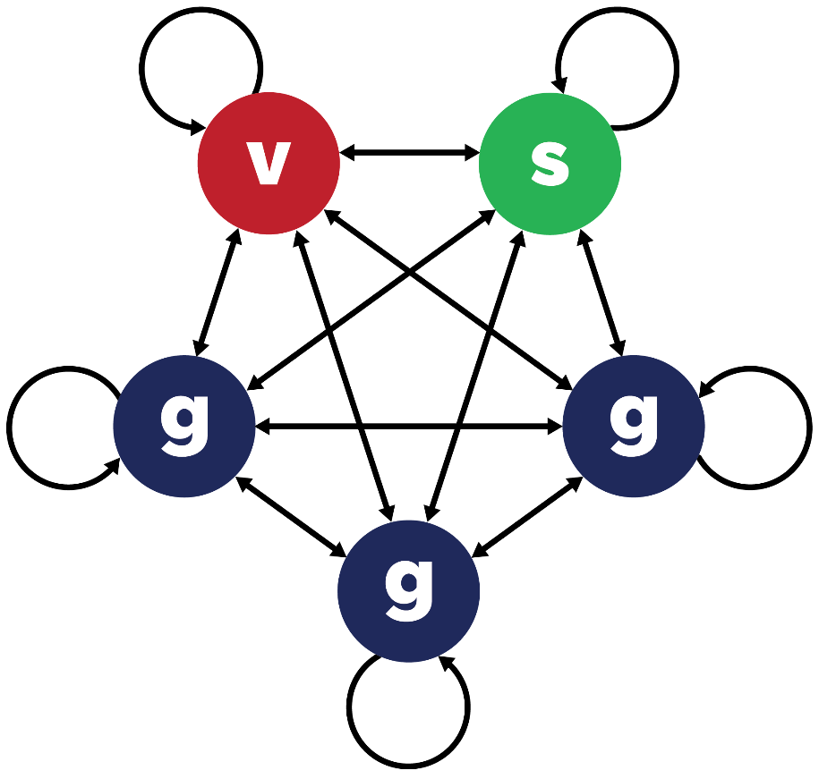

Figure 1. Contact structure for the 20-20-60 model. There are 5 segments, each comprising 20% of the total. v = vulnerable; s = shielders; g = general population. Transmission occurs within and between segments. Transmission rates within and between the three g segments are always homogenous, but may vary within and between segments of different types.

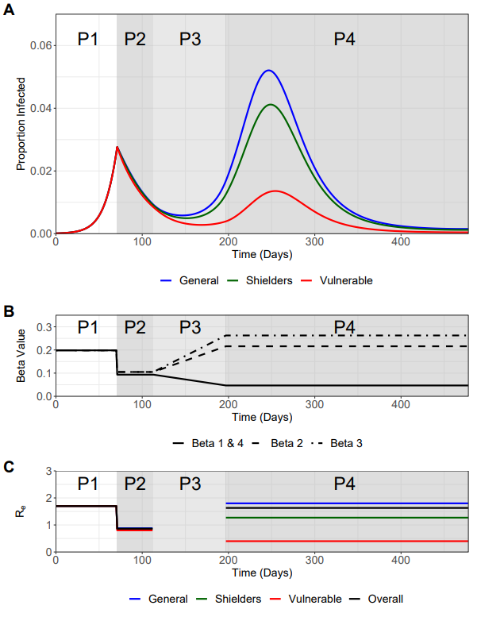

**Figure 2. Trajectory plots for the proportion infected in the vulnerable, shielders and general populations, with accompanying β and Re plots**. Phases 1-4 are indicated. A) Trajectory plots of the proportion of those infected in the vulnerable (green), shielders (red) and general (blue) populations, shading depicts the different phases of enhanced shielding intervention. B) Values for the different β over the course of the simulation as they are implemented for the different intervention phases. C) Values of the corresponding Re values (colours) for the different subpopulations and the overall Re (black) during the different intervention phases.

**Figure 3. Sensitivity analyses.** Plots show the relative height of 2nd peak versus 1st peak Iv as a function of relevant parameter value. Dotted lines represent peaks of equal height. A) Relative values of R­e in P3/P4. Second peak is higher for relative value >X.X, corresponding to R­e>X.X. B) Compliance in P3/P4. 100% compliance equates to P4 Re=0.4 (baseline value); 0% compliance equates to pre-lockdown value of Re=1.7. Second peak is higher for compliance <XX%. C) Re in all phases. P1 Re values are shown; Re values in other phases are scaled accordingly. Second peak is higher for P1 Re <X.X. D) Duration of immunity (expressed as 1/ ζ). Second peak is higher for 1/ ζ <XX days.

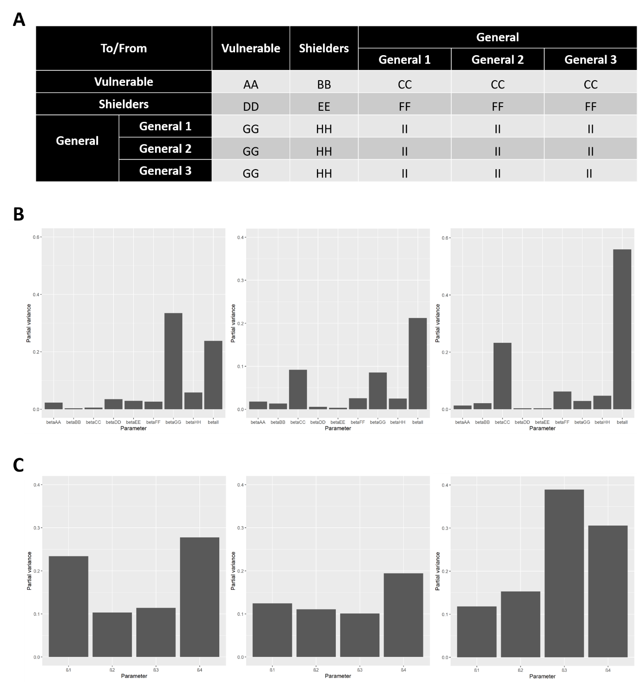

**Figure 4. Results of a global sensitivity (FAST) analysis on three key outcome measures with regards the proportion of the vulnerable population that become infected (Iv)**: 1) the height of the second peak of Iv; 2) whether the second peak of Iv is higher than the first peak and 3) cumulative Iv one year after the start of the lockdown. The bars show the partial variance of the individual model parameters. Higher bars indicate greater sensitivity of the model to that parameter. See Supplementary Methods for details of the sensitivity analysis and parameter ranges used. A) Description of explored β value “blocks” for the sensitivity analysis. β1, β2, β3 and β4were broken down further to assess the sensitivity of the system to these values in greater detail. Lettering denotes the explored β in the FAST analysis. B) Sensitivity of the model outcome measures to the β values specified in A). C) Sensitivity of the model outcome measures to β1, β2, β3 and β4.

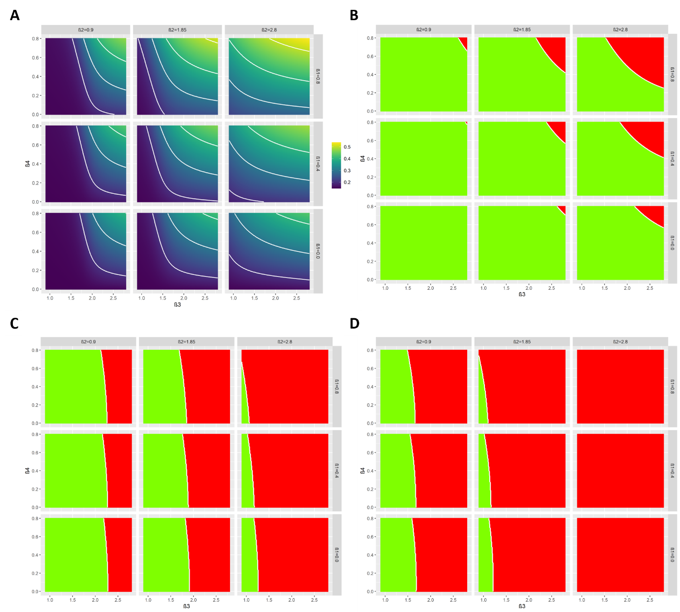

**Figure 5. Heat maps showing the trade-off between relaxation (left to right on horizontal axis) and increasing protection (top to bottom on vertical axis)**. A) Heat maps describing the cumulative infected vulnerable fraction (Iv) one year after the start of lockdown for different combinations of β3 and β4 for different values of β1 (rows) and β2 (columns). B) As A) but for whether the second peak of Iv is lower (green) or higher (red) than the first peak. C) As (B) but all 2nd peaks (Iv, Ih, Ig) smaller than 1st peaks (green). D) As (B) but dI­/dt is negative or zero for at least 1 year after the start of lockdown for all I-compartments.

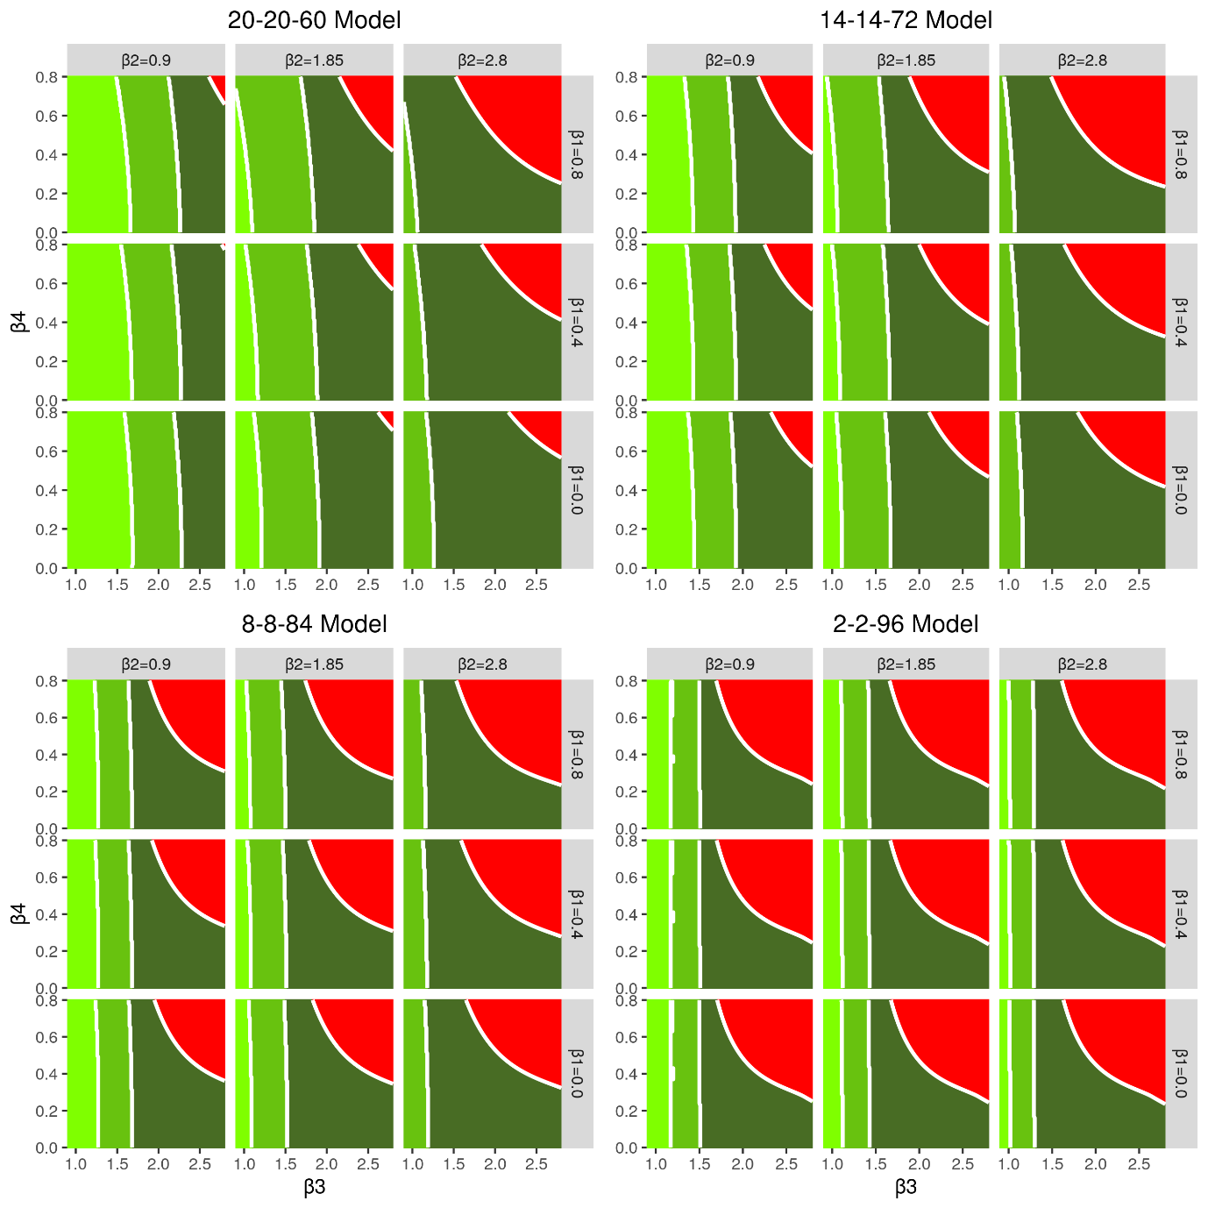

**Figure 6. Heat maps showing the trade-off between relaxation (left to right on horizontal axis) and increasing protection (top to bottom on vertical axis) for the different models considered**. The green shading indicates which of the policy objectives is met: Dark green: second peak of Iv is lower than the first peak. Middle green: as dark green plus all 2nd peaks (Iv, Ih, Ig) lower than 1st peaks. Light green: As middle green but dI­/dt is negative or zero for at least one year after the start of lockdown for all I-compartments. Red: none of the policy objectives are met.

Tables

Table 1. Comparison of the estimated distribution of COVID-19 burden for the 20-20-60, 14‑14-72, 8-8-84 and the 2-2-96 scenarios.

|  |  |  |  |  |  |  |
| --- | --- | --- | --- | --- | --- | --- |
| Model | Segment | Proportion of population | Fraction of severe disease burden | Relative risk of severe disease | Cumulative incidence* | Proportion of severe disease burden* |
| 20-20-60 | v | 0.20 | 0.80 | 16 | 0.19 | 0.55 |
| s + g | 0.80 | 0.20 | 1 | 0.60 | 0.45 |
| 14-14-72 | v | 0.14 | 0.68 | 13.1 | 0.22 | 0.40 |
| s + g | 0.86 | 0.32 | 1 | 0.68 | 0.60 |
| 8-8-84 | v | 0.08 | 0.50 | 11.7 | 0.24 | 0.25 |
| s + g | 0.92 | 0.50 | 1 | 0.74 | 0.75 |
| 2-2-96 | v | 0.02 | 0.20 | 12.3 | 0.27 | 0.08 |
| s + g | 0.98 | 0.80 | 1 | 0.79 | 0.92 |

*Over one year period from the end of P2 (days 113 to 478).

**SUPPLEMENTARY INFORMATION**

**METHODS SUPPLEMENT**

**Description of Model Structure**

A frequency-dependent SIRS-type metapopulation model was used to explore the effect of enhanced shielding with three population categories being modelled:

* Vulnerable population (Nv) - Those who have risk factors that place them at elevated risk of developing severe disease if infected with COVID-19 and so would remain shielded whilst the rest of the population is gradually released from lockdown.
* Shielders population (Ns) - Those who have contact with the vulnerable population and include carers, certain care workers and healthcare workers. It is expected that they would also continue some shielding whilst the rest of the population is released from lockdown.
* General population (Ng). The population that are not vulnerable or shielders.

For the baseline scenario, a population structure of 20% vulnerable, 20% shielders and 60% general was used (Table M1). A total infectious fraction of 0.0001 (split equally across the population) was used as the initial conditions to seed infection. Model parameters were chosen to best describe the transmission dynamics of COVID-19 in the UK using current assumptions (as of publication) regarding the values of key epidemiological parameters (Table M2).

The SIRS model assumes that the number of new infections in a sub-population is a function of the fraction of the sub-population that is susceptible (SX), the fraction of the sub-population that is infectious (IX) and the rate of infectious transmission between the two sub-populations (βX). Infectious individuals subsequently recover at a rate γ that equates to an infectious period of 8.56 days. Recovered individuals are assumed to lose immunity and return to being susceptible over 365 days (Eqn 1.1). All β were calculated as a function of the reproduction number and gamma (γ) (eqn 1.2). Gamma itself is calculated as the reciprocal of the generation time, which is a function of the baseline basic reproduction number (R0) and the baseline doubling time (T2) (eqn 1.3).

**Table M1**. SIRS Model Compartments and Initial Conditions for Baseline Scenario

|  |  |  |
| --- | --- | --- |
| Compartment | Description | Initial Conditions |
| Sv | Susceptible fraction of the vulnerable population | 0.19998 |
| Ss | Susceptible fraction of the shielder population | 0.19998 |
| Sg | Susceptible fraction of the general population | 0.19994 |
| Iv | Infectious fraction of the vulnerable population | 0.00002 |
| Is | Infectious fraction of the shielder population | 0.00002 |
| Ig | Infectious fraction of the general population | 0.00006 |
| Rv | Recovered fraction of the vulnerable population | 0 |
| Rs | Recovered fraction of the shielder population | 0 |
| Rg | Recovered fraction of the general population | 0 |

**Table M2**. Parameter Descriptions and Values

|  |  |  |
| --- | --- | --- |
| Parameters | Description | Value |
| R0 | Baseline basic reproduction number | 2.8 |
| T2 | Baseline doubling time | 3.3 days |
| βx | Per capita rate of infectious transmission | Varies (see Table 3) |
| γ | Per capita rate of recovery | 0.1167 day-1 |
| ζ | Per capita rate of immunity loss | 0.0027 day-1 |

Eqn1.1

Eqn1.2

Eqn1.3

**WAIFW Matrix and Modelling Transmission**

A “who acquires infection from whom” (WAIFW) matrix was created to describe transmission between the three sub-populations (Table M3). For the baseline scenario of 20-20-60, the general population was split into three subgroups, to explicitly model differences in contact/transmission between the general sub-population and the vulnerable/shielders.

Segregating of the general population into sub-groups allowed for greater flexibility in the frequency-dependent framework, enabling variation to be modelled in the transmission rates between different sub-populations, whilst, critically, maintaining a globally balanced and fixed R0/Re value throughout the model. However, the three general population sub-groups are functionally identical, with homogenous mixing in the general sub-population assumed to occur and with β values being identical within/between the general sub-groups.

Four β values were used to parameterise the model: β1 describes transmission within/between the vulnerable and shielder subpopulations, β2 describes transmission between shielders and the general subpopulations, β3 describes transmission within the general subpopulations and β4 transmission between general and vulnerable subpopulations (Table M3).

**Table M3**. Generic WAIFW matrix used for the model and the transmission parameters β, which defines transmission between subpopulations

|  |  |  |  |  |  |  |
| --- | --- | --- | --- | --- | --- | --- |
| To/From | | Vulnerable | Shielders | General | | |
| **General 1** | **General 2** | **General 3** |
| Vulnerable | | β1 | β1 | β4 | β4 | β4 |
| Shielders | | β1 | β1 | β2 | β2 | β2 |
| General | **General 1** | β4 | β2 | β3 | β3 | β3 |
| **General 2** | β4 | β2 | β3 | β3 | β3 |
| **General 3** | β4 | β2 | β3 | β3 | β3 |

The WAIFW matrix structure allows for similar levels of transmission within the vulnerable and between the protective shielders sub-population (β1). Shielders themselves can subsequently contact the general sub-population at a different level (β2), with the general population having greater levels of contact with one other (β3). Transmission between the vulnerable and general sub-populations was assumed to be much lower than with other sub-populations (β4).

**Modelling Enhanced Shielding**

To model the effect of an enhanced shielding strategy on COVID-19 transmission, four intervention “phases” were considered. These phases describe social distancing measures which aim to control a COVID-19 epidemic. Interventions were modelled as alterations in the effective reproduction number (Re) values (translated into β values) (eqn 1.2), representing changes in infectious pressure resulting from these control measures.

In the context of an enhanced shielding strategy, the intervention phases were assumed to impact the Re values (and subsequently the β values) differently within/between each sub-population, to reflect the loosening or tightening of social distancing measures throughout the progression of the outbreak (Table M4). The transition from phase 1 to phase 2 represents the hard lockdown implemented on the 24th March 2020, phase 3 represents a progressive release (for the general subpopulation) or tightening (for the vulnerable subpopulation) of restrictions applied over a 12-week period. Phase 4 represents the end point of the gradual transition of phase 3. The model simulations start on day 0 and lockdown is implemented on a selected “trigger day" which corresponds to where the proportion of total recovered individuals (Rtot) is 0.06 seven days after the trigger day. The Re values that are modelled in the baseline scenario are also shown in Table M4 and were used to calculate the β values used in each phase and the resulting β values are shown in Table M5.

**Table M4**. Description of intervention phases

|  |  |  |  |  |  |  |
| --- | --- | --- | --- | --- | --- | --- |
| Phases | Description of Intervention Phase | Duration | Re used to calculate β* | | | |
| **β1** | **β2** | **β3** | **β4** |
| Phase 1 | Represents the “business as usual” approach that was operating pre-lockdown. We assume a pre-lockdown Re=1.7, reflecting pre-existing reductions to transmission from a baseline R0 = 2.8. | Up until Rtot(tp+7) = 0.06  (tp=day 71) | 1.7 | 1.7 | 1.7 | 1.7 |
| Phase 2 | Represents the nationwide lockdown that was applied approximately equally to all subpopulations. We assume that pre-existing shielding in the vulnerables has resulted in reductions to Re relative to the shielders and general subpopulations (Re = 0.8/0.9). | 6 weeks | 0.8 | 0.9 | 0.9 | 0.8 |
| Phase 3 | Represents a progressive change in restrictions – a progressive release of regulations to the general subpopulation and a progressive tightening of restrictions applied to the vulnerable subpopulation. R­e values change linearly from phase 2 to phase 4 over the course of 12 weeks. | 12 weeks | Linear Change to Phase 4 | | | |
| Phase 4 | Represents the long-term application of the released restrictions to the general subpopulation and long-term enhanced shielding of vulnerable subpopulations. We assume that Re is reduced further in the vulnerables by ½ as part of the enhanced shielding strategy. Based on a “back-to-normal” R0 = 2.8, we model a partial return back-to-normal for the shielders (even greater return for the remainder). We assume a central value between lockdown and back to normal for the shielders (0.9 < R < 2.8), and a central value between pre-lockdown and back-to-normal for the general sub-population (1.7 < R < 2.8). | Until end of simulation  (1 year after lockdown ends, i.e. 478 days from start of simulation) | 0.4 | 1.85 | 2.25 | 0.4 |

* All Re values used are for illustrative purposes and are best guess for the effect of interventions and SDMs based on expert opinion. tp=trigger point (day number) for start of lockdown.

**Table M5**. β values used for baseline scenario.

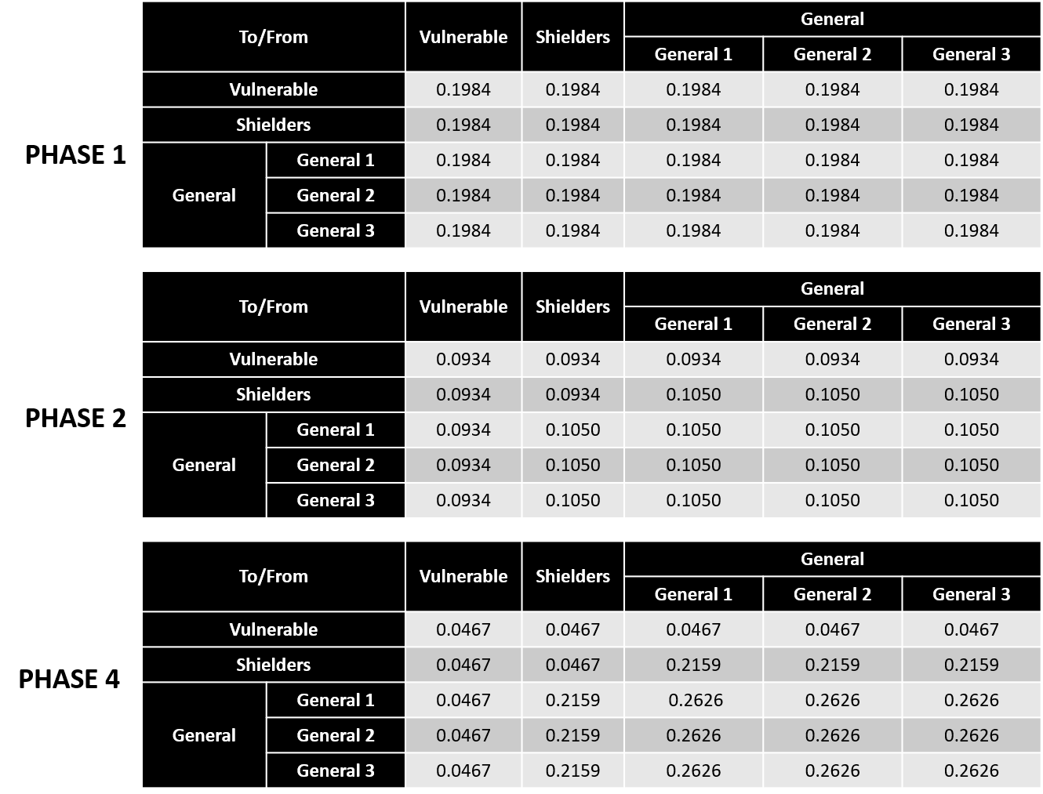

**Sensitivity Analysis**

To test the susceptibility of the core results to key parameters and uncertainty in the model formulation, several sensitivity analyses were conducted. These explored:

1. Varying P1 Re values from the baseline value of 1.7 (explored range of 1.4 – 2.0)
2. Varying P2 Re values from the baseline value of 0.8/0.9 (explored range of 0.6/0.7 – 1.0/1.1)
3. Varying the trigger day from day 71 to day 46 and 96.
4. Varying the duration of the P3 ramp-down (β1 & β3) and ramp-up (β1 & β3) from baseline of 12 weeks (explored range of 6 – 18 weeks)
5. Assessing the sensitivity of the main model output to individual beta values in the WAIFW matrix
6. Adhering to compliance by the vulnerable population increasing all β’s to and from the vulnerable population (explored 100% - 0% compliance).
7. Varying P4 R­e values from thebaseline values by increasing or decreasing all β’s in P4 by 25%.
8. Impact of testing of the shielder population is tested by reducing the transmission from the shielders by 50% or 100%.
9. Sensitivity analysis for the ratio of proportion of shielders to vulnerable op. The following structures where explored: 40-20-40 (v-s-g) (2:1 ratio), 20-20-60 (1:1 ratio, baseline) and 20-10-70 (1:0.5 ratio).

**Description of FAST Analysis**

We determine which model parameters have most influence on the outcome values (height of second peak fraction of the vulnerable population that are infectious (Iv), whether the second peak of Iv is higher than the first peak and the cumulative fraction of Iv one year after the start of lockdown) by computing the total sensitivity index *D*Ti using the extension of Fourier amplitude sensitivity test (FAST) as described in Saltelli et al. (1999).

The extended FAST method is a variance-based, global sensitivity analysis technique that has been largely used for studying complex agricultural, ecological and chemical systems (e.g. Makowski et al. 2006; Neumann et al. 2009). Independently of any assumption about the model structure (such as linearity, monotonicity and additivity of the relationship between input factors and model output), the extended FAST method quantifies the sensitivity of the model output with respect to variations in each input parameter by means of spectral analysis.

It provides measures of the amount of variance of the prevalence that arise from variations of a given parameter in what is called a total sensitivity index, *D*Ti. It therefore captures the overall effect of parameter variations on the chosen outcome values (i.e. including first- and higher-order interactions between model parameters). For example, a value of *D*Ti = 0.10 indicates that 10% of the total observed variation of the prevalence is explained by the parameter under consideration. The sensitivity analysis was carried out using R (R Core Team, 2020). For the sensitivity analysis, we used a parameter range of -25% to +25% of the baseline value for all parameters under investigation.

**Disease burden**

The effect of the enhanced shielding strategy was assessed in four population structures as part of a model sensitivity analysis. These comprised the baseline 20-20-60 model, 14-14-72 model, 8-8-84 model and a 2-2-96 model. With the numbers representing the percentage of the entire population attributable to the vulnerable, shielders and general populations respectively.

An underlying β distribution was sampled 1000 times to create a simulated population distribution. The *ineq* R package was used to calculate the value of the Lorenz curve at each population percentile. The shape parameters of the β distribution were fitted so that the Lorenz curve had a value of 0.8 at the 20th population percentile (Figure S4). The values at the 14th, 8th, 4th and 2nd percentile were then deduced.

The relative risk of severe disease was calculated as a ratio of the risk of severe disease in the vulnerable population to the risk of severe disease in the remainder of the population (shielders plus general population). Model output was used to calculate the cumulative incidence over a 365 day period after P2, in order to assess the impact of each considered population structure on the efficacy of the enhanced shielding strategy. The proportion of the severe disease burden attributable to each sub-population was calculated using the relative cumulative incidence in each sub-population, scaled by the proportion of severe disease risk attributable to each sub-population.

**Software used**

SIRS model implemented in R and C++ independently (code available at <https://github.com/bvbunnik/COVID-19-enhanced-shielding.git>). Package “desolve” was used in R to implement model structure and analysis. Package “ggplot2” was used for all output plotting.

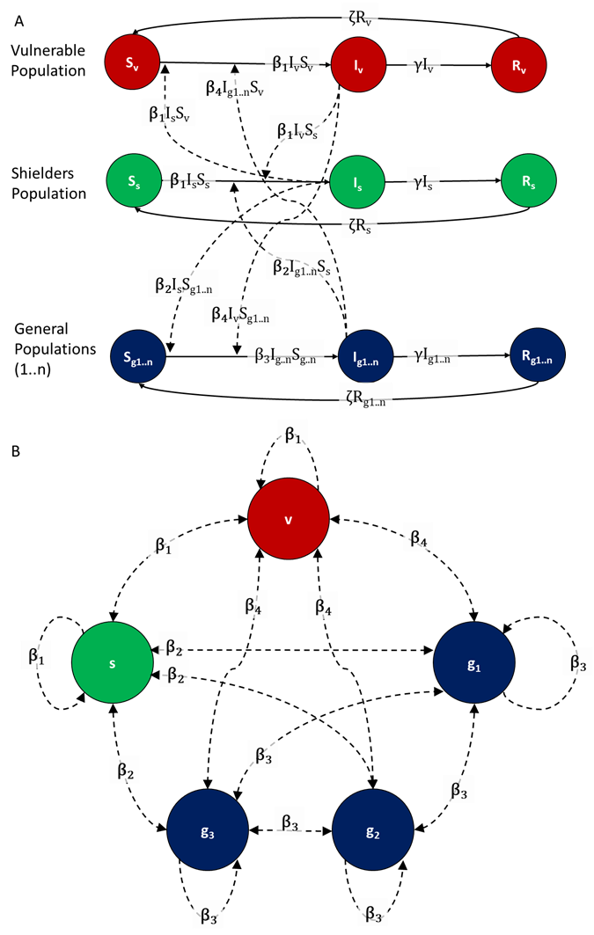

**Figure M1**. SIRS model structure (A) defined by Susceptible, Infectious and Resistant compartments and (B) the 20-20-20-20-20 network structure with five equal sized populations: vulnerable (v), shielders (s) and three general populations (g1, g2 and g3). This illustrates the baseline with five equal sized populations, but can be extended to n equal sized populations by increasing the number of general subpopulations. We define four values of the rate of transmission (β) with β1 defining the rate of transmission within and between the vulnerable and shielders; β2 defines transmission between shielders and general subpopulations; β3 defines transmission between the general populations and β4 defines transmission between general and vulnerable populations. People in the Infectious compartments recover at rate γ and people in the recovered compartments lose immunity at rate ζ.

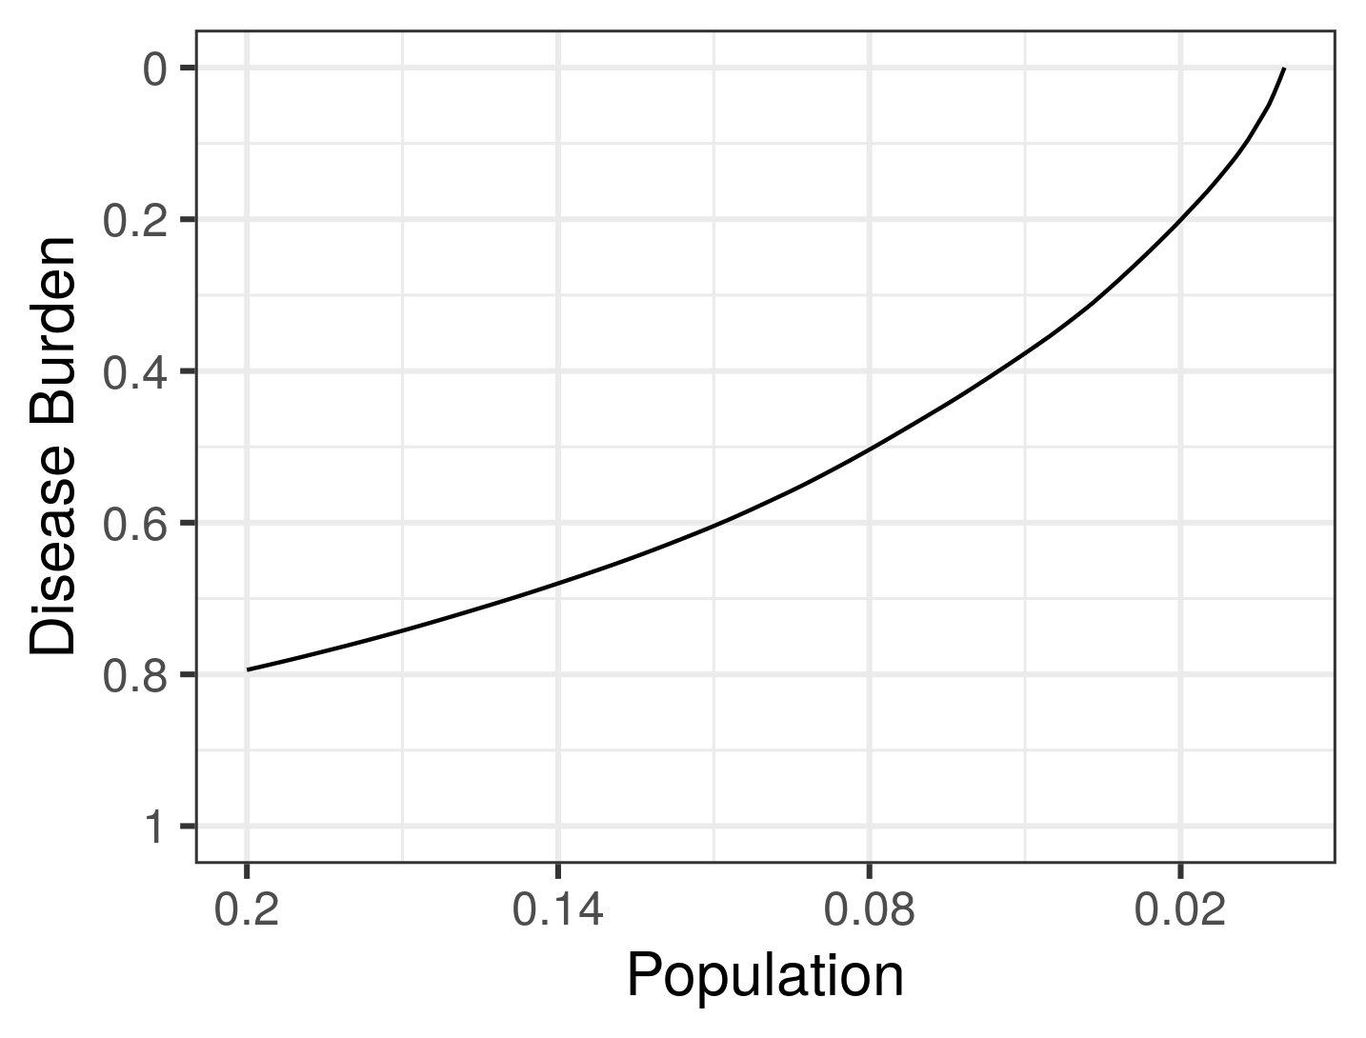

**Figure M2. Lorenz curve to estimate the disease burden for a given fraction of the population.**

**References**

Saltelli A, Tarantola S, Chan KPS. (1999). A quantitative model-independent method for global sensitivity analysis of model output. Technometrics 41, 39–56. (doi:10.2307/1270993)

Makowski D, Naud C, Jeuffroy M-H, Barbottin A, Monod H. (2006). Global sensitivity analysis for calculating the contribution of genetic parameters to the variance of crop model prediction. Reliability Eng. Syst. Safety 91, 1142–1147. (doi:10.1016/j.ress.2005.11.015)

Neumann MB, Gujer W, von Gunten U. (2009). Global sensitivity analysis for model-based prediction of oxidative micropollutant transformation during drinking water treatment. Water Res. 43, 997–1004. (doi:10.1016/j.watres.2008.11.049)

R Core Team (2020). R: A language and environment for statistical computing. R Foundation for Statistical Computing, Vienna, Austria. URL:https://www.R-project.org/.

SUPPLEMENTARY FIGURES

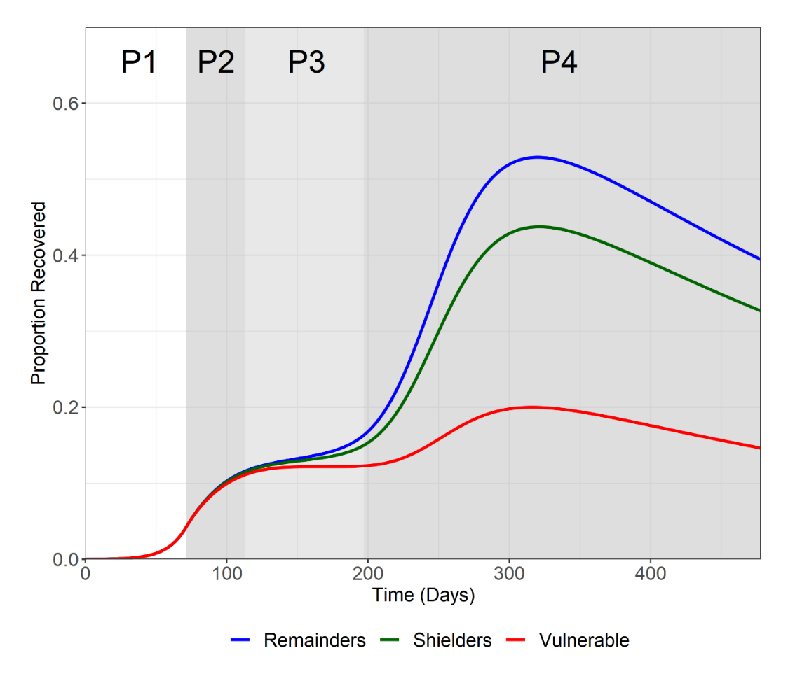

**Figure S1. Immune proportion.** Trajectory plots of the immune (R) proportion in the vulnerable (green), shielders (red) and general populations (blue). Phases are labelled P1-P4. Note that for the baseline scenario immunity decays over time (average duration = 365 days).

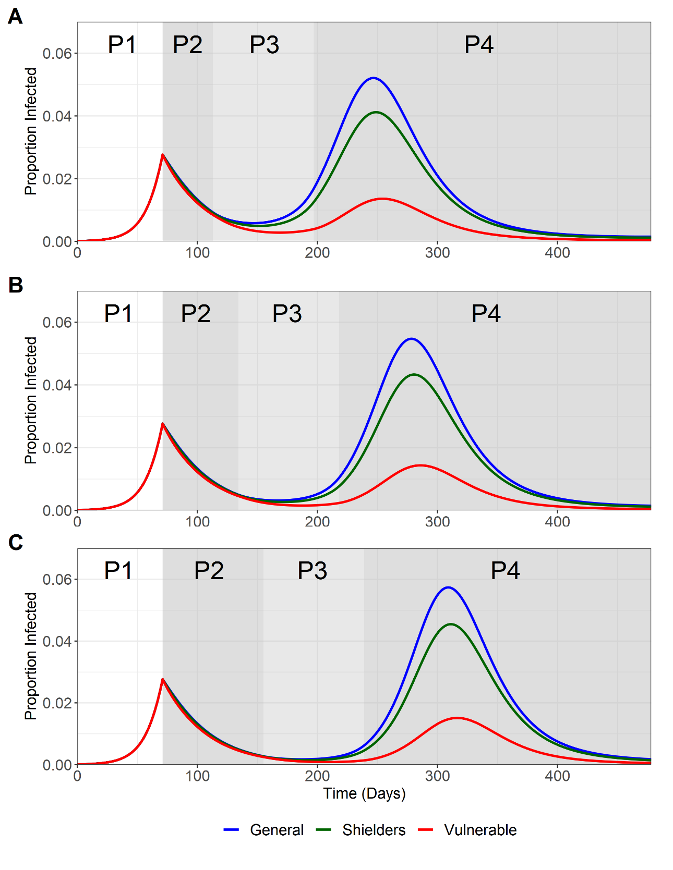

**Figure S2.** **Sensitivity analysis for duration of P2.** Trajectory plots for Ig (blue), Is (green) and Iv (red). Phases are labelled P1-P4. A) 6 weeks (baseline). B) 9 weeks. C) 12 weeks.

**Figure S3.** **Sensitivity analysis for duration of P3.** Trajectory plots for Ig (blue), Is (green) and Iv (red). Phases are labelled P1-P4. A) 6 weeks. B) 12 weeks (baseline). C) 18 weeks.

**Figure S4. Sensitivity analysis for varying the trigger point.** Trajectory plots for Ig (blue), Is (green) and Iv (red) for different starting conditions for P2 in terms of t and Itotal(t). Phases are labelled P1-P4. A) Itotal(46)= 0.0042. B) Itotal(71)= 0.0277). C) Itotal(96) = 0.0.093.

**Figure S5. Sensitivity analysis for P2 β values.** Trajectory plots for Ig (blue), Is (green) and Iv (red). Phases are labelled P1-P4. A) 6 weeks. B) 12 weeks (baseline). C) 18 weeks. Variation is expressed in terms of the Re values used to calculate β1 = β4 (first number) and β2 = β3 (second number) in P2. A) 0.6 and 0.7. B) 0.8 and 0.9. C) 1.0 and 1.1.

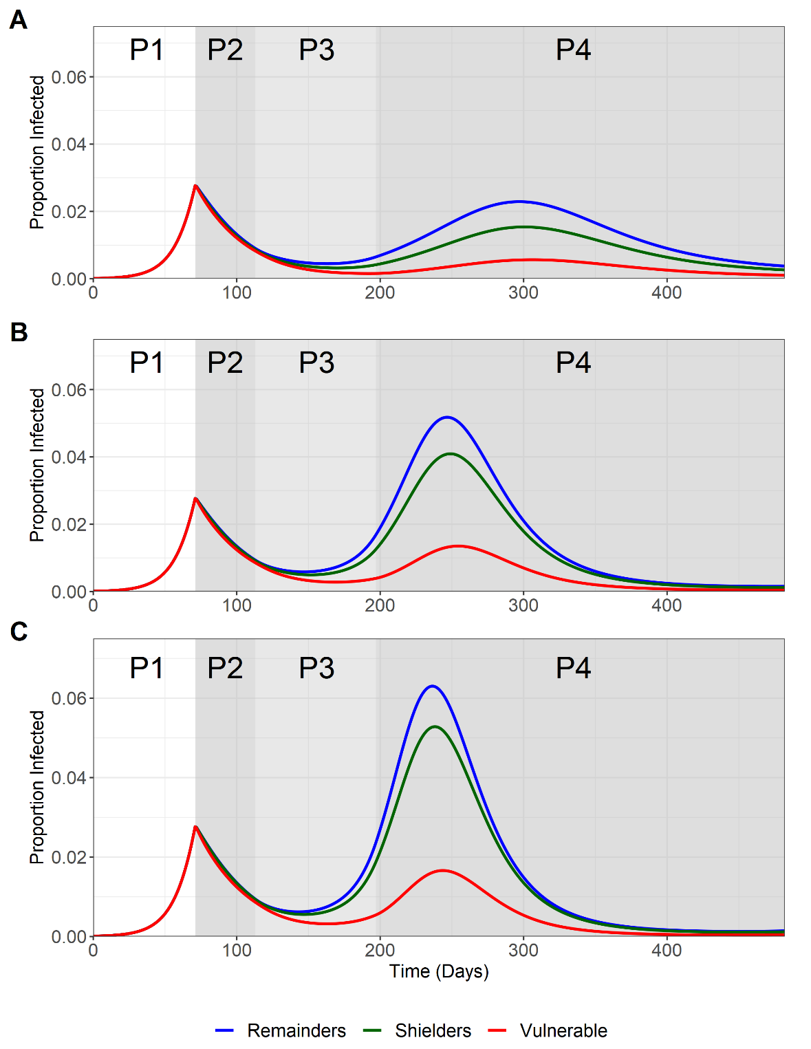

**Figure S6. Sensitivity analysis for the ratio of shielders to vulnerable**. As Figure 2A for 40-20-40 (2:1 ratio), 20-20-60 (1:1 ratio, baseline) and 20-10-70 (1:0.5 ratio) models.

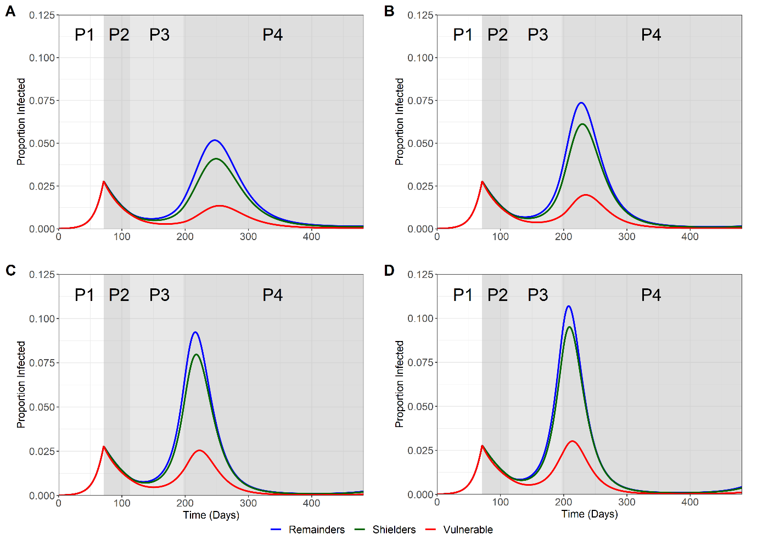

**Figure S7.** As Figure 2A for the 20-20-60 (baseline), the 14-14-72, the 8-8-84 and the 2-2-96 models.

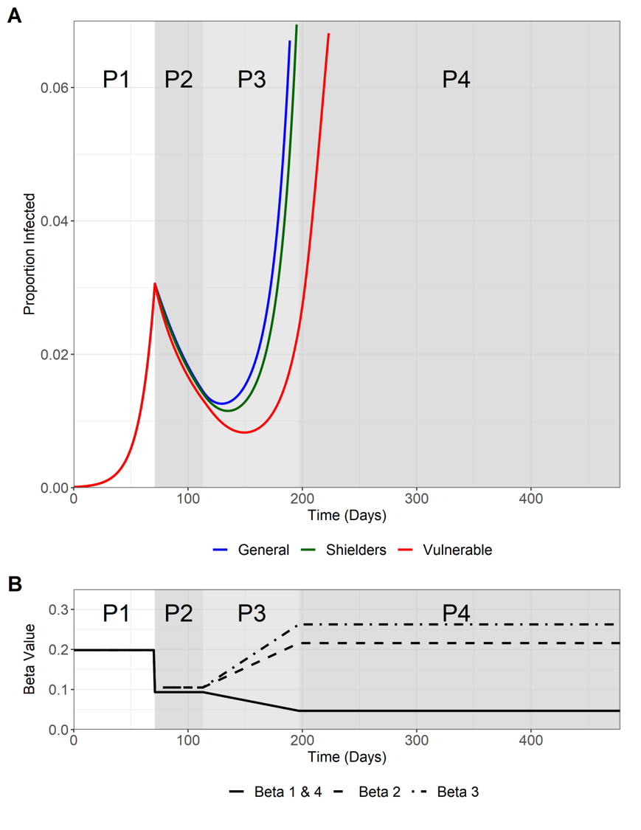

Figure S8. Outputs of SIS model with no acquired immunity; all other parameter values as Figure 2.

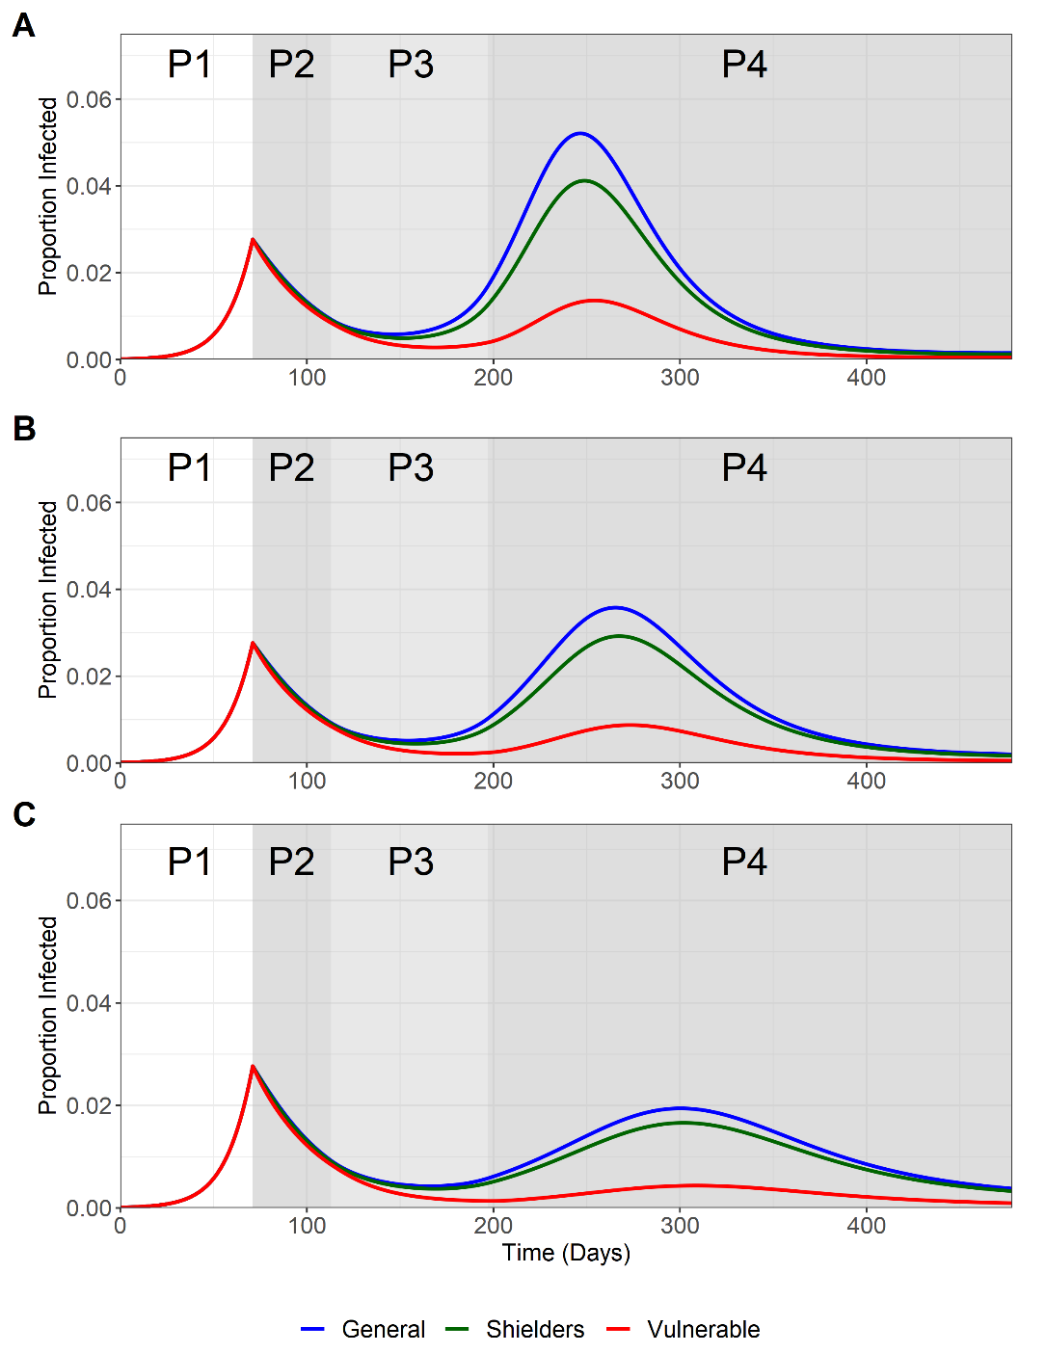

**Figure S9. Impact of screening shielders for infection**. As Figure 2A with all transmission from shielders (β blocks BB, EE and HH – see Figure 4) reduced. A) By 0% (baseline). B) By 50%. C) By 100%.

SUPPLEMENTARY TABLE

Table S1. COVID-19 Shielding in the UK. A) Definition of vulnerable population [NHS Digital, 2020; Scottish Government, 2020]. B) Shielding advice [Public Health England, 2020].

**A**

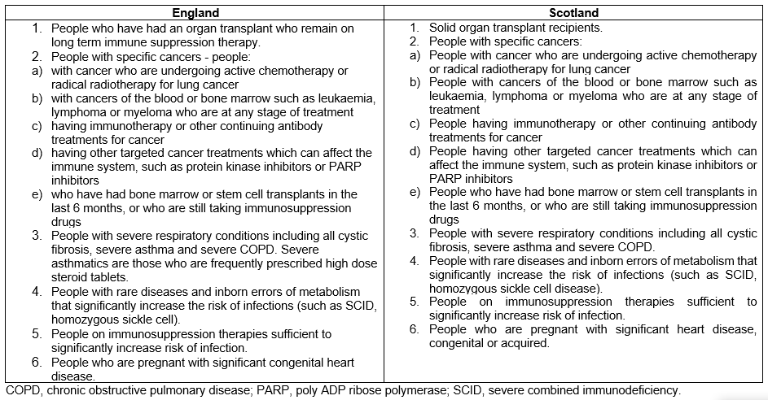

**B**

